Roller Mixer—RM100
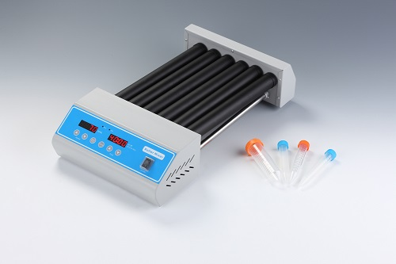
Description:
RM100 Roller Mixer is a compact digital roller for use with a variety of containers, including test tubes, centrifuge tubes and roller bottles. Roller Mixer provides a efficient rolling and swinging motion, ideal for mixing blood samples, viscous substances and liquid-solid suspensions. It is used for prevention of blood coagulation and immune precipitation etc. From blood collection tubes to roller bottles, the Roller Mixer is the deal choice for research and clinical laboratories.

Features:
- Digital set-up for speed and time with independent LED display.
- Continuous or timer operation.
- Maintenance free brushless DC motor.
- Maximum stirring speed up to 99rpm.
- Rolling & Swinging action for complete mixing.
- With special Forwards/Reverse motion.
- Compatible for use with wide range of tubes/bottles from 8mm to 200mm diameter.

Parameters:
Model | RM100
Speed range | 20~99rpm
Operation mode | Rolling & Swinging
Timing range | 1min~99h59min/∞
Forwards/Reverse motion | Yes
Timer for Forwards/Reverse | 30sec~99min59sec
Amplitude | 25mm
Roller quantity | 6
Roller length | 280mm
Max. load | 4kg
Power | 15W
Voltage | AC100~240V 50/60Hz
Dimension(mm) | 480×250×100
Weight(kg) | 3.8

